# 

# 

**Oasis**

**Setup Document**

Version 1.3

28/03/2017

**TABLE OF CONTENTS**

**1** **PREFACE 3**

**2** **CLIENT 3**

**3** **PROCESSES 4**

**4** **FUNCTIONAL REQUIREMENTS 5**

**5** **USER INTERFACE 6**

1. **Preface**

Within this document our organization will briefly show information for the formal client and our team along with what our agreements with the client are and what will be the processes of enrolling, paying and visiting the event. Also, will be specified what may be done in those exceptional cases. Additionally, the functional requirements grouped by application and MoSCoW list including a description of the user interface. In each chapter, you can find specific information on the main topic and a detailed description below. What is more, this document is going to be occasionally updated with the decisions we make in the future.

1. **Client**

|  |  |
| --- | --- |
| **Name** | Emin Thaqi |
| **Address** | Rachelsmolen 1 |
| **City** | Eindhoven |
| **Country** | Netherlands |
| **Post code** | 5612 MA |
| **Telephone** | +31 610176464 |

The client, Mr. Emin Thaqi, is requesting a system for a social event which contains a website and a few applications, connected to a database, suiting his requirements. The deliverable at the end is the system, including a project plan, the following setup document, a presentation, a database design and a process report. The non-deliverable is everything, not mentioned in this file.

1. **Our Team**

|  |  |
| --- | --- |
| **Company Name** | Bear With Me |
| **Address** | Geer 20 |
| **City** | Eindhoven |
| **Country** | Netherlands |
| **Post code** | 5640 MA |
| **Telephone** | +31 612176589 |
| **Team members** | Emil Karamihov  Martin Savov  Hristiyan Tarnev  Joseph Winterdal |

1. **Processes**

People are encouraged to register by website for visiting the events and receiving the RFID chip for less money, rather than those which have purchased it on the spot.

The RFID chip is the best option available for this kind of task. Keeping the identity of client and linking his/her event-account with money he/she has/hasn’t deposited. The chip bracelet will be enquired at the main entrance after going through an id check to see if this is the person registered through the website. If he/she hasn’t registered he/she will be offered to register, but for a higher price. Standard price 55 euros.

Some of the ways to deposit money in the event-account is by entering the wanted amount when registering for the event online in the website. The only other possible way is by the PayPal terminal located in the park. The terminal is linked with the organization PayPal. After some period of time PayPal will supply us with a text log with all of the transactions made in a certain period of time. The only way to pay for event, food, renting and other is by the RFID-bracelet linked with the event-account of the client.

It is possible to make a reservation for a camping spot for at most 6 people with standard recipient price 30 euros (only one person is considered as recipient) and every other person is considered as a guest. The recipient must pay additionally 20 euros for every other guest.

A group of friends decide they want to go on a vacation park/event and they search such events on the internet. They come across our event on Facebook and decide that they want to go to this event. On our Facebook page it links to the event website. They visit this website and pay for the event thus receiving an account and a receipt. They have to now go to said event location and go to the entrance area. At this area they will show their order receipt number and a valid id and will gain entrance to the event. Only people that camp can stay overnight. All other facilities will close at a certain time. If u decide to not attend any more you cannot refund your ticket. You cannot have an account if you did not pay for at least one ticket.

If the person hasn’t paid enough to visit the event or the entrance he will be politely asked to do so with the original price he register with. Otherwise he will not be allowed to enter the event.

Dropping out is possible and will not be refunded from the organization.

1. **Functional requirements**

Website for registering and getting information

An application to be used at the entrance of the event.

An application to be used at the entrance of the camping.

An application to be used at the shops.

An application to be used at the stand, where you can loan materials.

An application to be used when a visitor leaves the event.

An application for the organization to inspect the status of the event.

An application to convert the information in the PayPal-text-file to the database.

|  |  |  |  |  |  |  |  |  |
| --- | --- | --- | --- | --- | --- | --- | --- | --- |
| Functions | Web-Site | App Entrance Event | App Entrance Camping | Shop | ISSD | App Exit Event | App Status | PayPal App |
| Used by staff | - | X | X | X | X | X | X | X |
| RFID-chip compatibility | - | X | X | X | X | X | - | - |
| Payments with RFID | - | X | X | X | X | - | - | - |
| Registration and on spot | X | X | X | - | - | - | - | - |
| Third party organizations  Compatibility  (Streams) | - | - | - | - | - | - | - | X |
| Sales | X | X | X | X | X | - | - | - |
| Rents | - | - | - | - | X | - | - | - |
| Athena server | X | - | - | - | - | - | - | - |
| MySQL database design  connection | X | X | X | X | X | X | X | X |
| Application with C# | - | X | X | X | X | X | X | X |

1. **User Interface**

All programs are Windows compatible. The user interface will contain buttons and labels that are going to guide the user. The information will be placed in a TextBox and the orders will be displayed in a ListBox. There will be displayed a short text that is explaining the meaning to the button and what function it will have. The currency that the programs are going to display user payment system will be in euro. Furthermore the interface will be user friendly so it can be used easily by the staff. The food orders are going to be explicit colorful and the buttons will be changed with an image of that item to make it easier to use.

**6.1. GUI Applications**

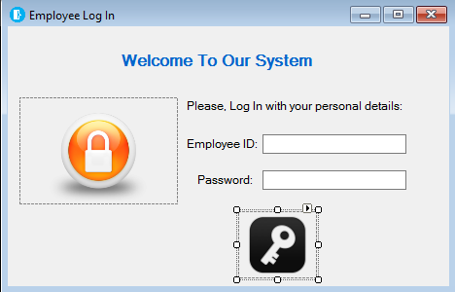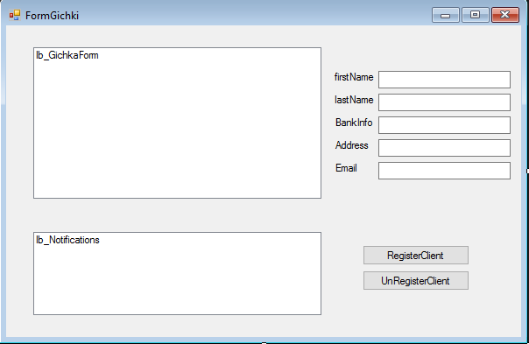

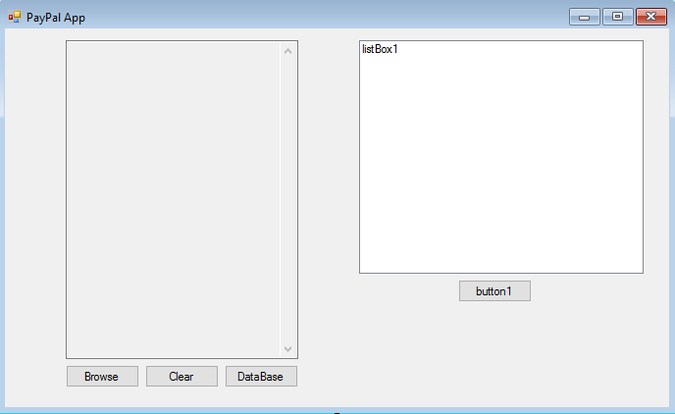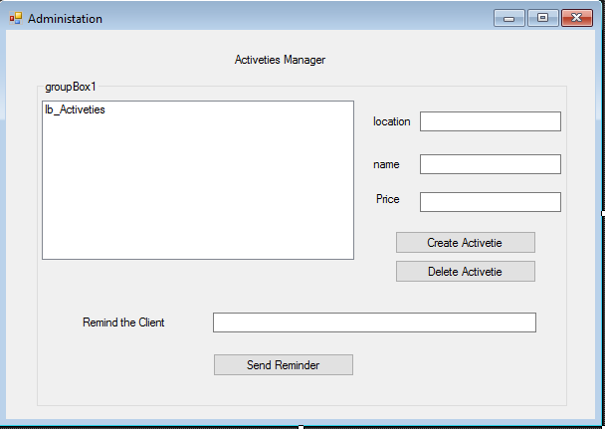e

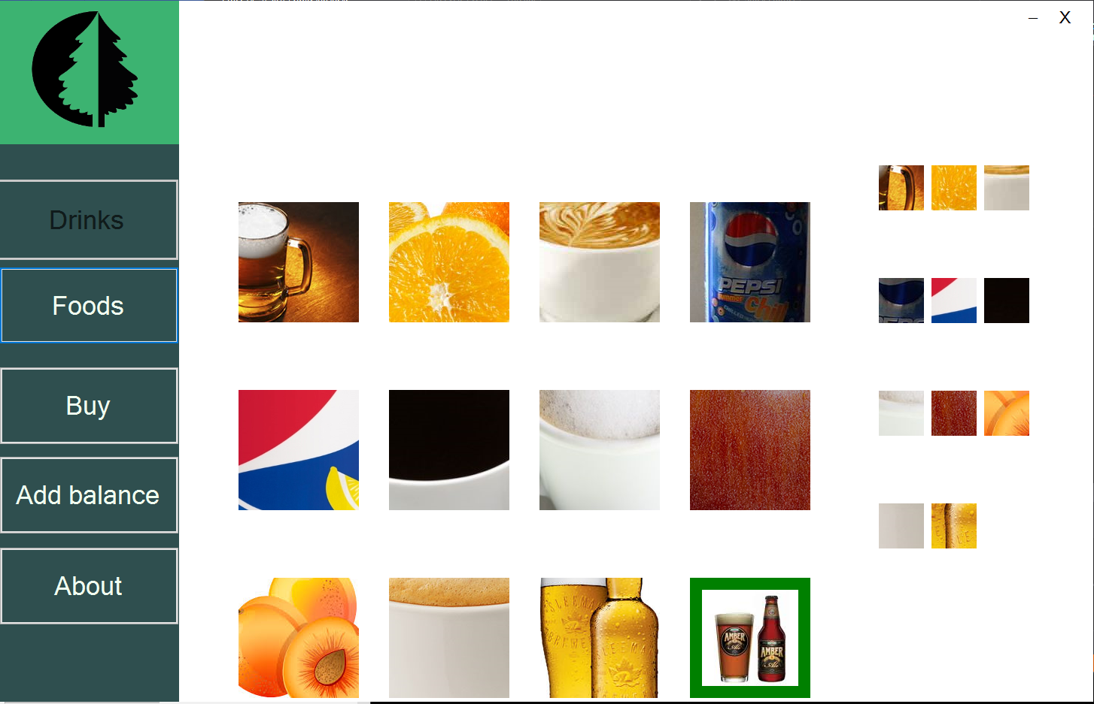

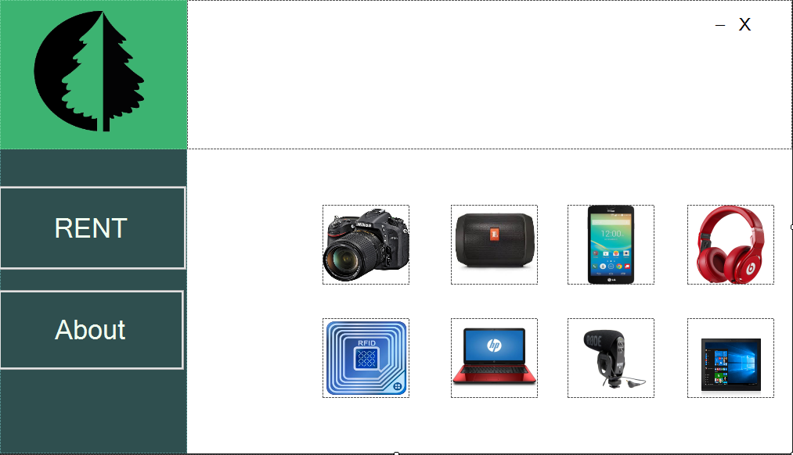

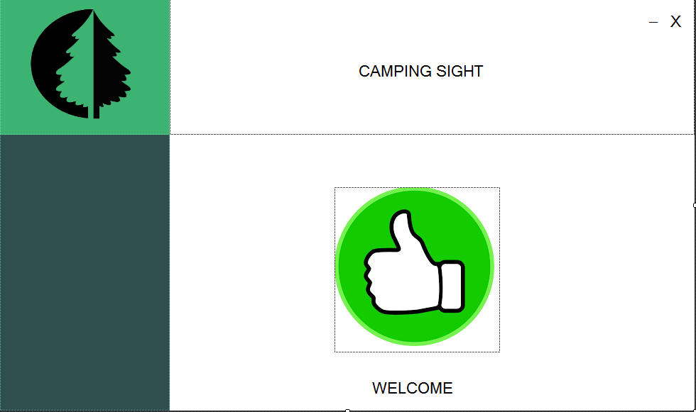

**6.2. UML**

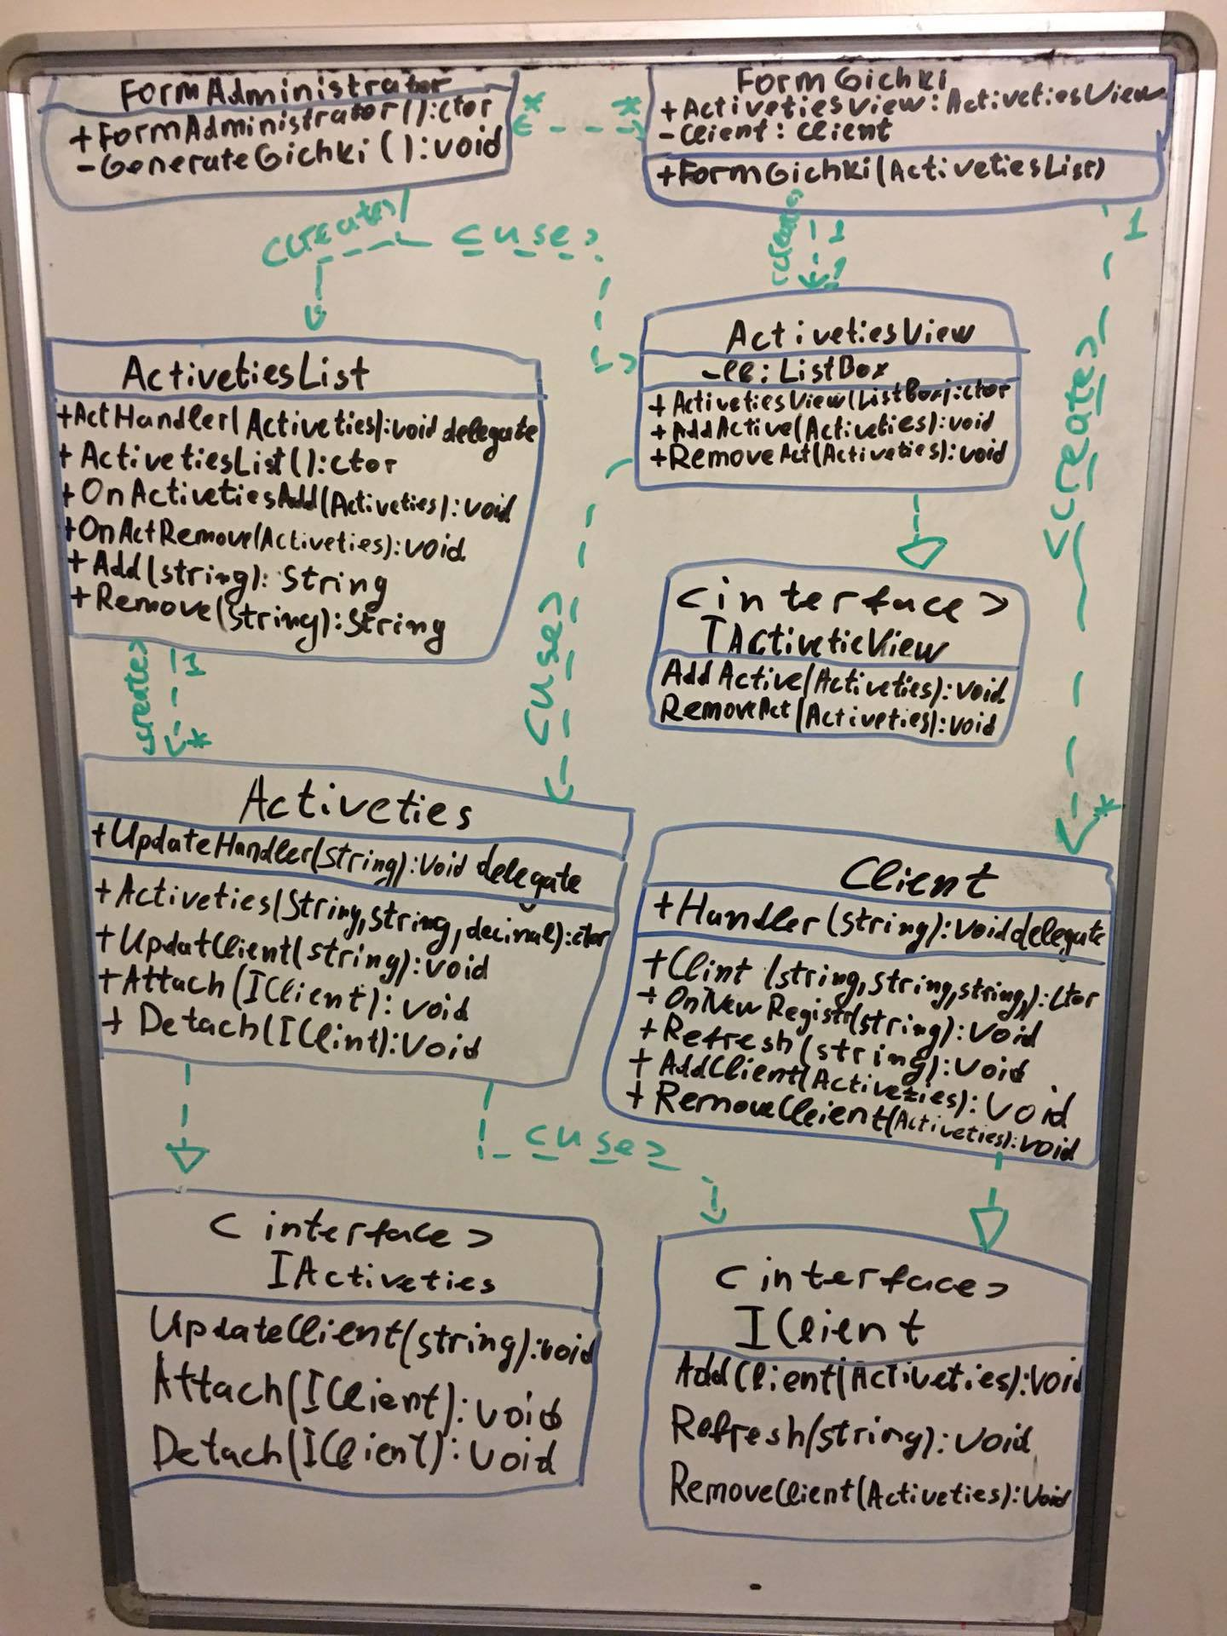

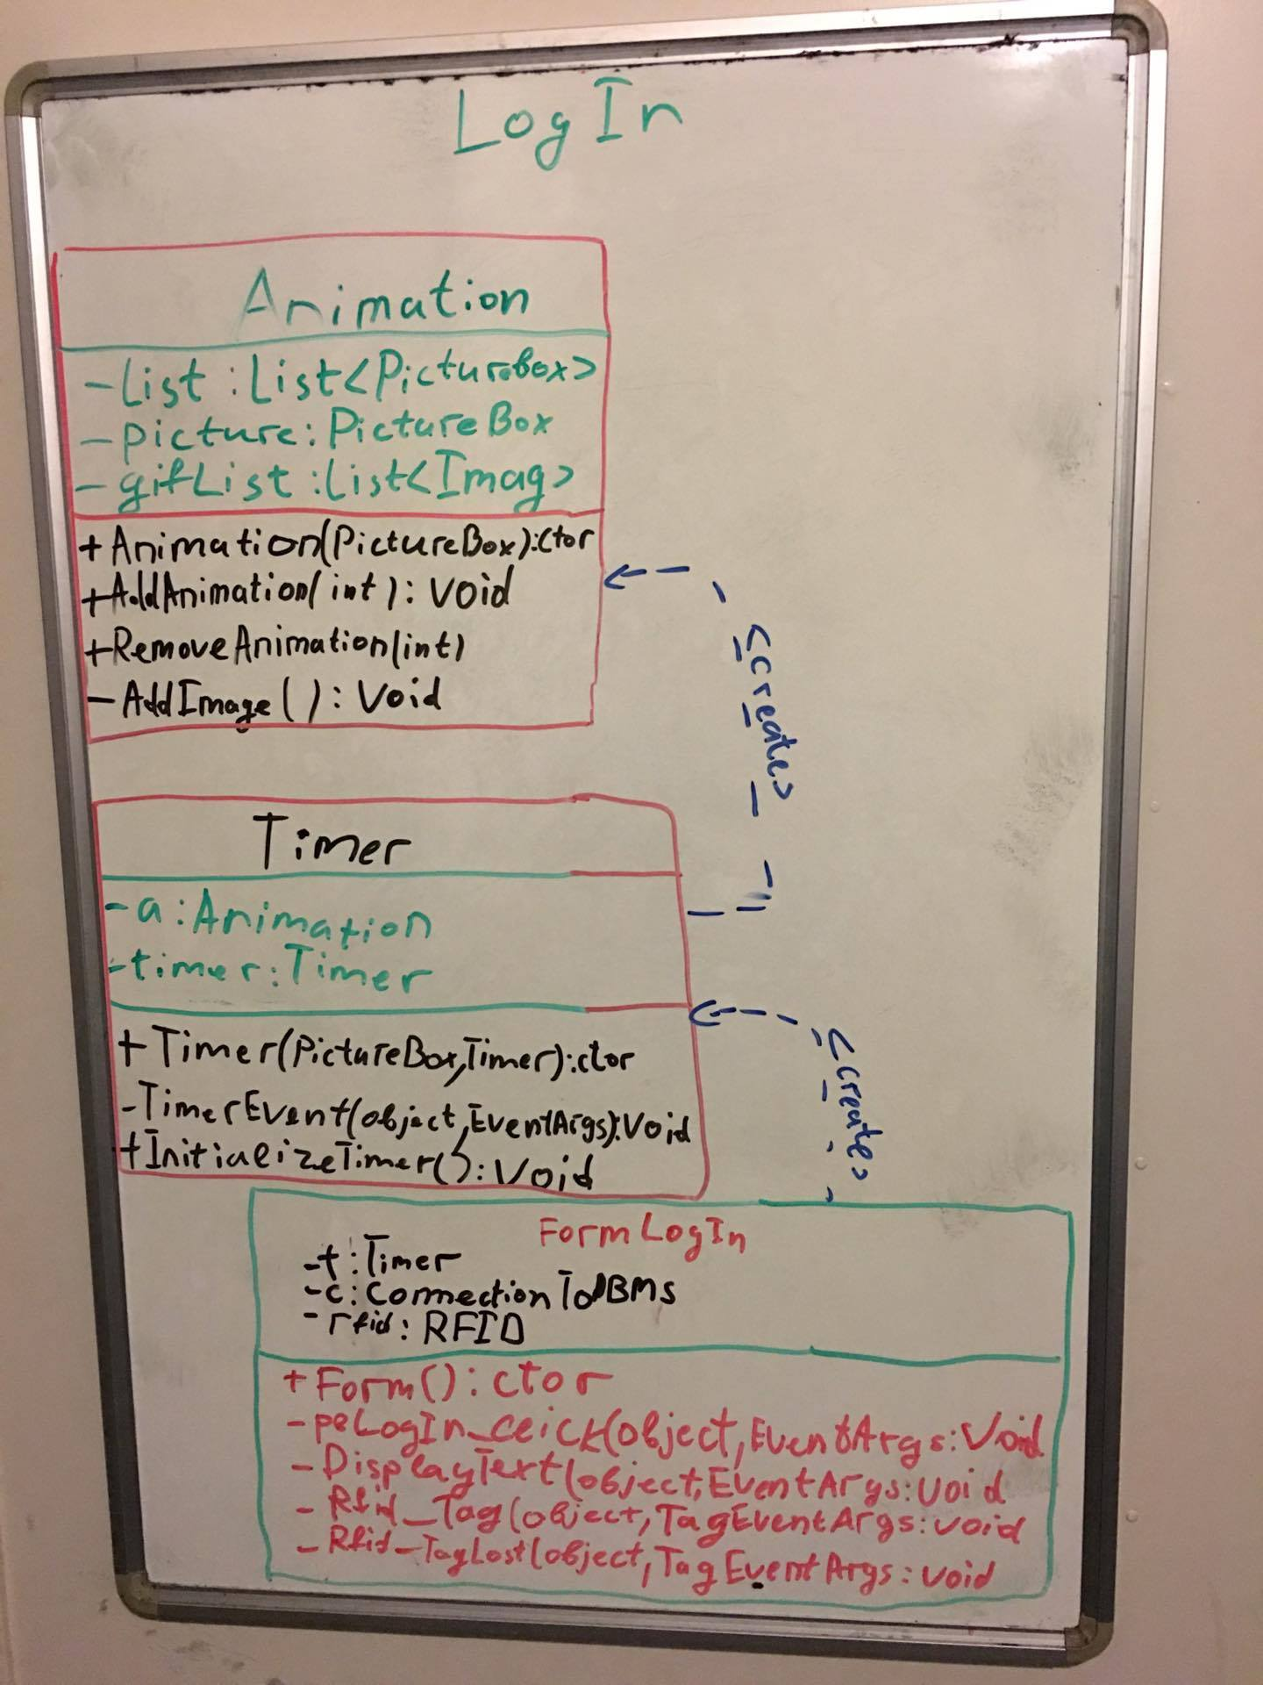

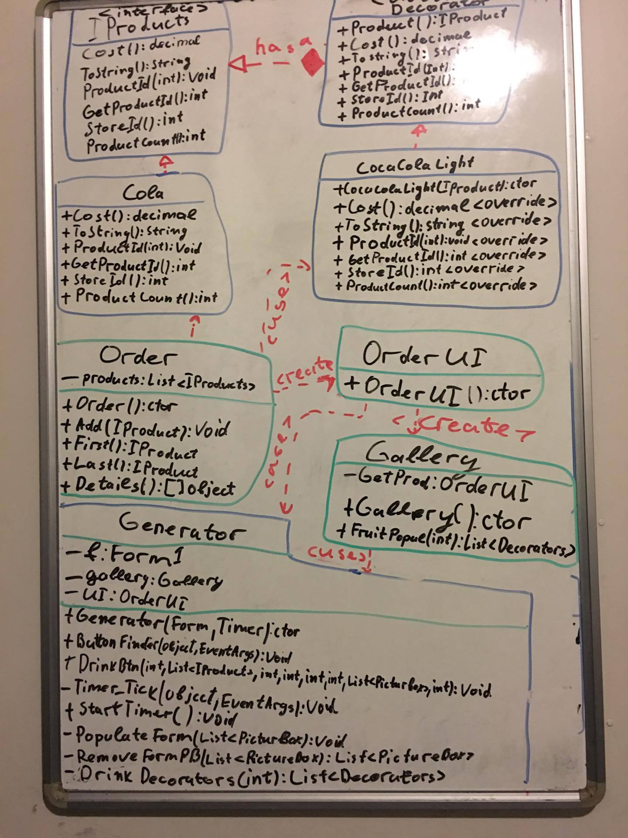

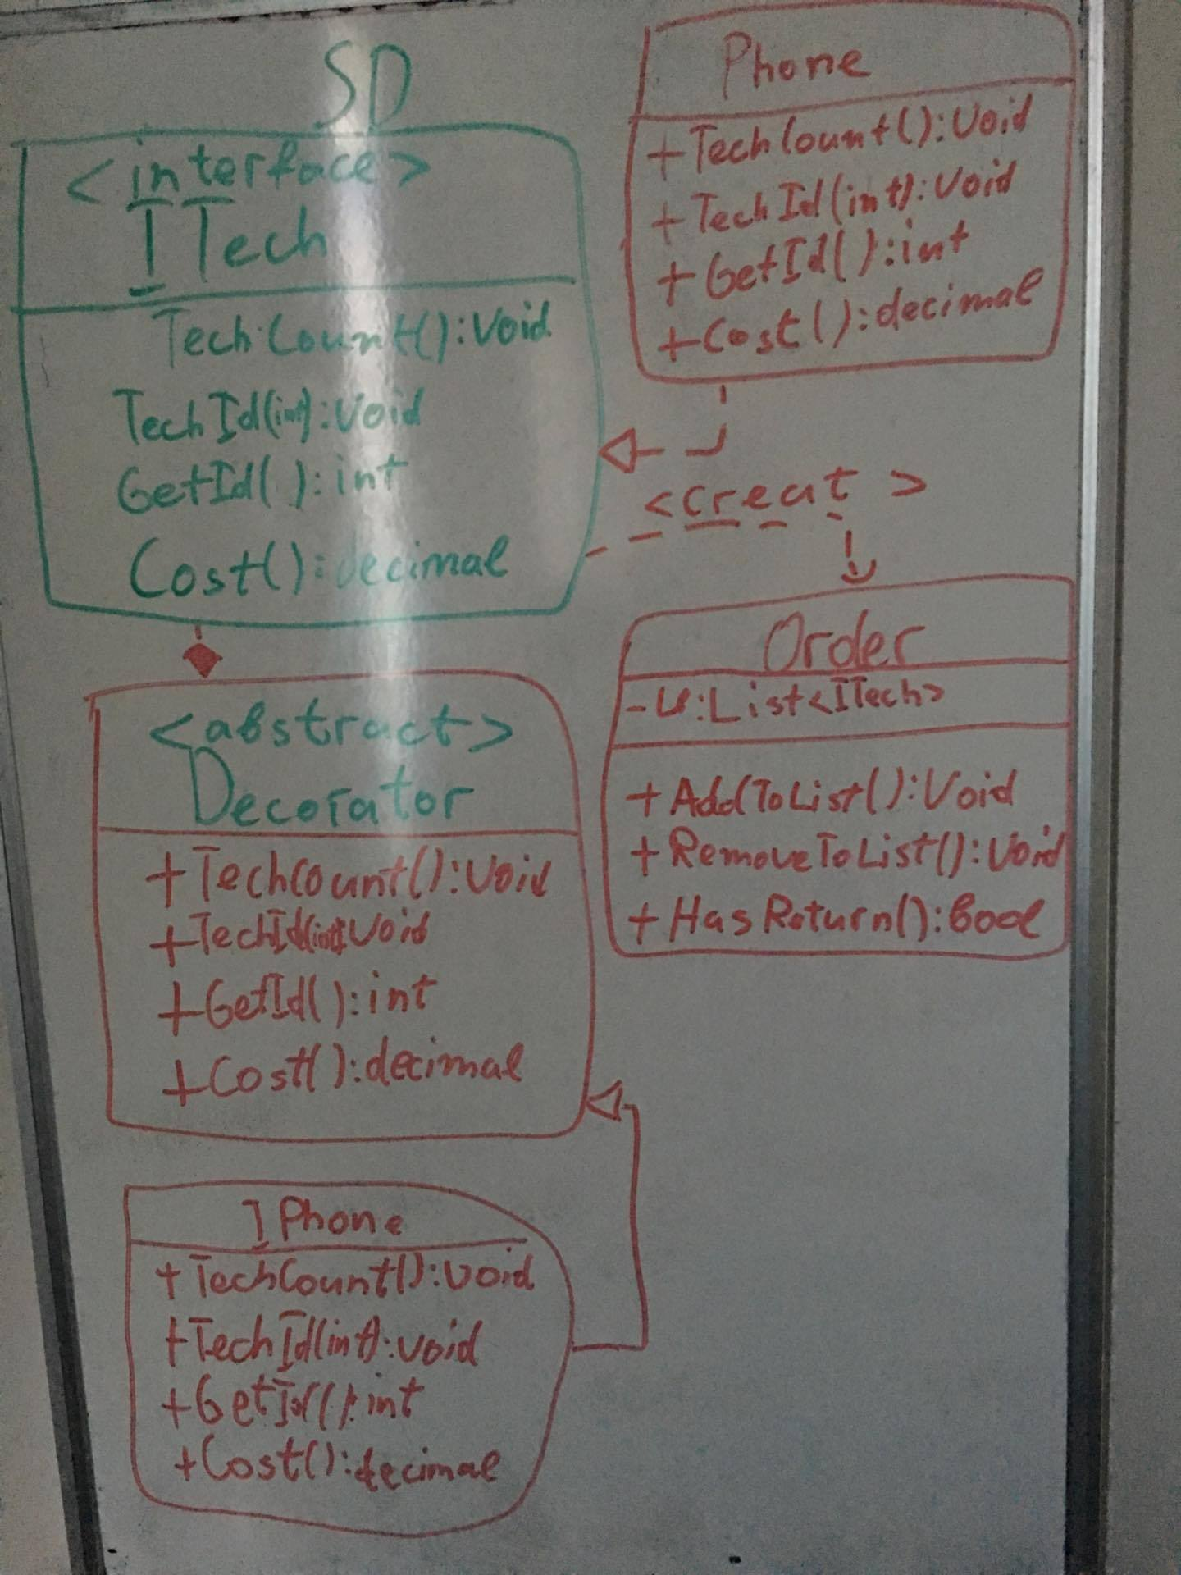

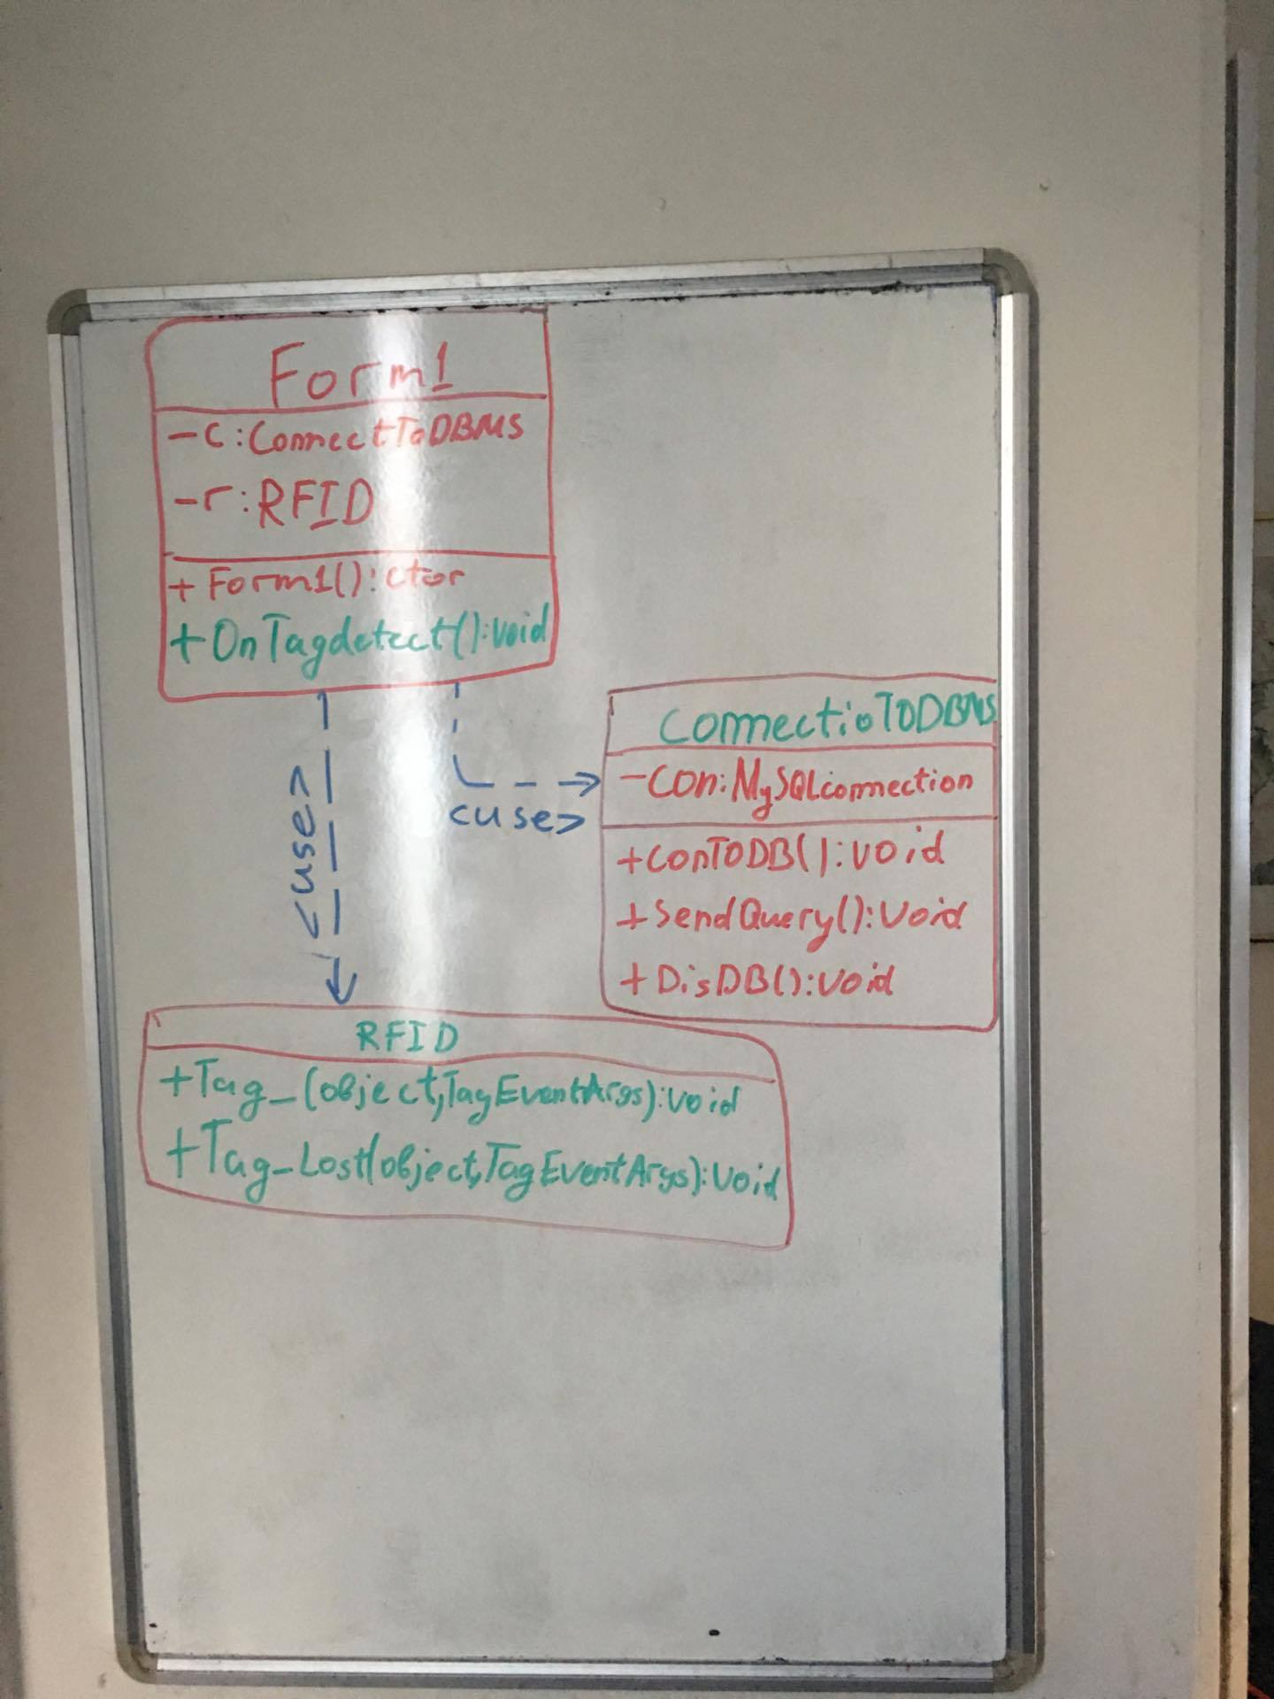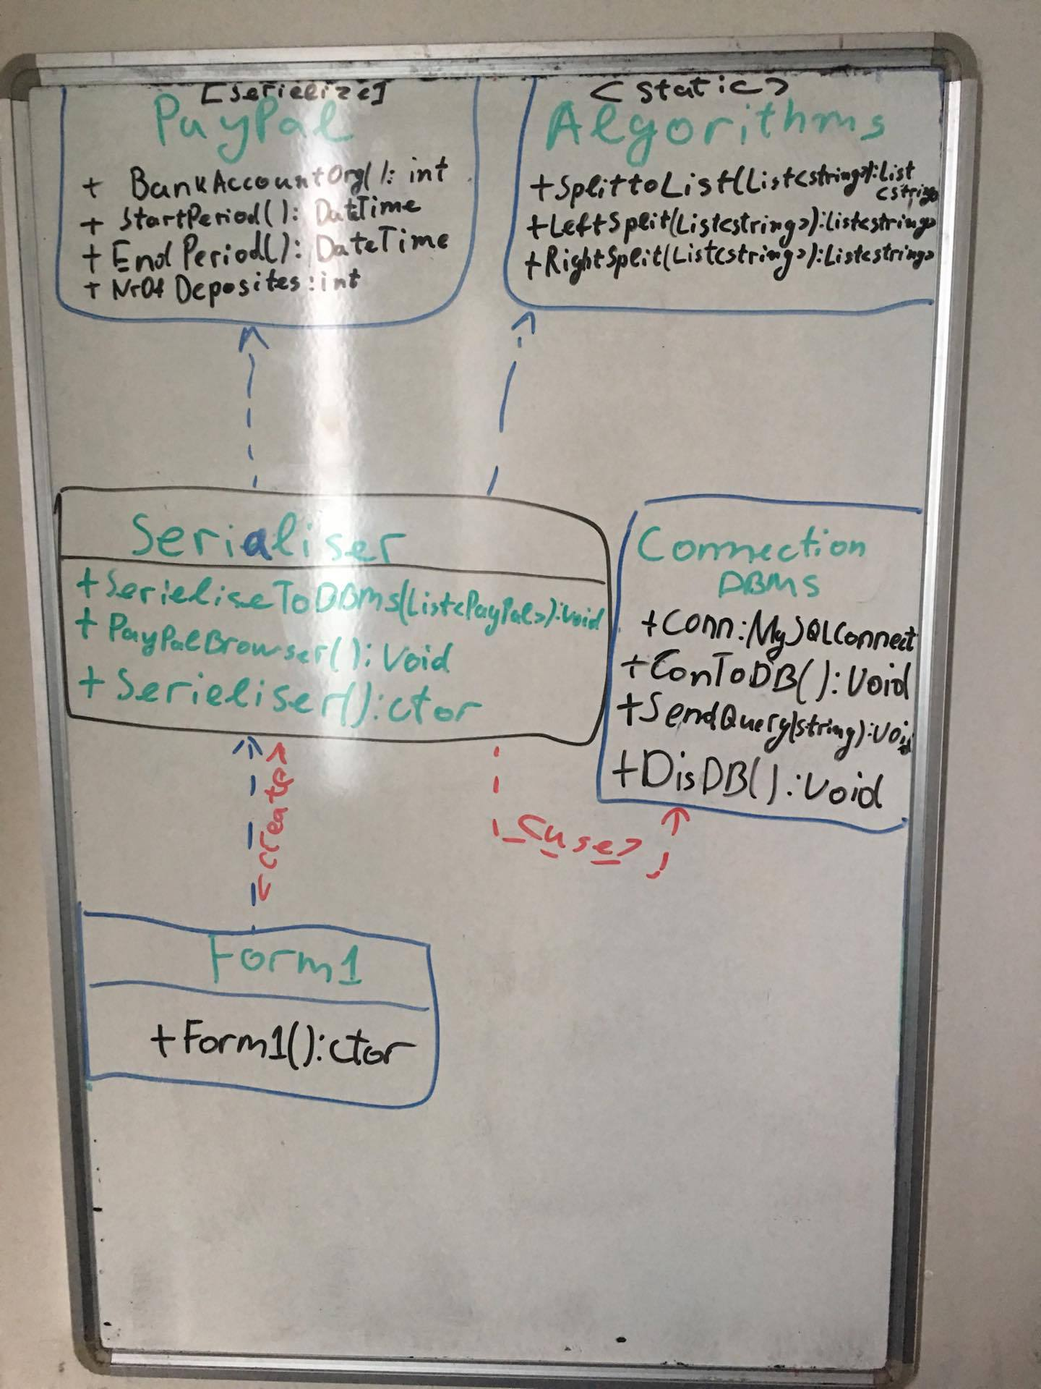

**6.3. Data Base Design**

